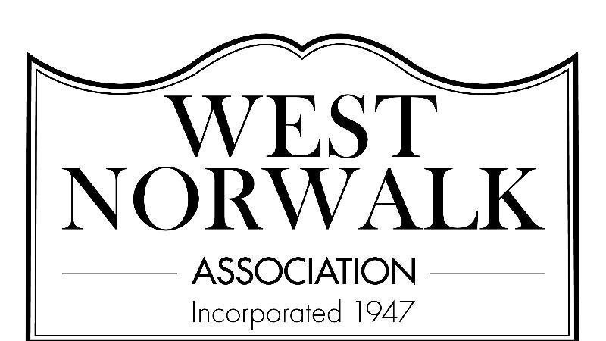

3/1/24

Dear West Norwalk Residents,

Today is March 1st! Can you believe it?? Hope everyone found the value we provided in the February meeting as we had a very informative discussion led by Bill Napoletano around the property revaluations. Hopefully, if you felt your assessment was off, you took action and contacted Bill or another licensed appraiser to challenge City Hall’s assessment.

For the next meeting, we will have no formal guest speaker so there will be ample time for members to come with ideas to make the neighborhood a better place or voice any concerns. It will also be an opportunity for members who have interest in joining the board or simply getting involved in some capacity to have the floor and introduce themselves

We will begin planning a social gathering for the Spring. More on this to come! Please reach out if you want to be involved in any way.

**The next meeting will be held on Monday, March 4th at 7:30 in the Fox Run Elementary School Library.** We hope to see many familiar and new faces in attendance!

If you have any questions or concerns, please reach out to the board ([board@westnorwalk.org](mailto:board@westnorwalk.org)) and we look forward to seeing you at the next meeting!

The West Norwalk Association Board of Directors

P.S. If someone forwarded you this email and you’d like to sign up for our mailing list, please do so at this [link](https://lp.constantcontactpages.com/sl/LvS9FAy/WNAsignup), or by emailing [board@westnorwalk.org](mailto:board@westnorwalk.org), or by using the QR code below.

